**ROBOTIC ARM WITH MACHINE LEARNING CAPABILITIES**

A PROJECT REPORT

Submitted by

**KNR18EE029 MOHAMMED SINAN M**

**KNR18EE031 MUHAMMED AJMAL ROSHAN**

**KNR18EE033 MUJEEB RAMAN M P**

**LKNR18EE065 MOHAMMED HASEEB K P**

**to**

the APJ Abdul Kalam Technological University

in partial fulfillment of the requirements for the award of the Degree

of

Bachelor of Technology

in

*Electrical & Electronics Engineering*



**Department of Electrical & Electronics Engineering**

**Government College of Engineering Kannur- 670563**

**SEPTEMBER 2020**

**ROBOTIC ARM WITH MACHINE LEARNING CAPABILITIES**

A PROJECT REPORT

**KNR18EE029 MOHAMMED SINAN M**

**KNR18EE031 MUHAMMED AJMAL ROSHAN**

**KNR18EE033 MUJEEB RAMAN M P**

**LKNR18EE065 MOHAMMED HASEEB K P**

*under the Supervision of*

Prof. SHARANYA V P

**to**

the APJ Abdul Kalam Technological University

in partial fulfillment of the requirements for the award of the Degree

of

Bachelor of Technology

in

Electrical & Electronics Engineering



**Department of Electrical & Electronics Engineering**

**Government College of Engineering Kannur- 670563**

**SEPTEMBER 2020**

**DECLARATION**

We undersigned hereby declare that the project report ( “Robotic Arm with Machine Learning Capabilities”), submitted for partial fulfillment of the requirements for the award of degree of Bachelor of Technology of the APJ Abdul Kalam Technological University, Kerala is a bonafide work done by us under supervision of Prof. Sharanya V P. This submission represents our ideas in our own words and where ideas or words of others have been included, I/We have adequately and accurately cited and referenced the original sources. We also declare that we have adhered to ethics of academic honesty and integrity and have not misrepresented or fabricated any data or idea or fact or source in our submission. We understand that any violation of the above will be a cause for disciplinary action by the institute and/or the University and can also evoke penal action from the sources which have thus not been properly cited or from whom proper permission has not been obtained. This report has not been previously formed the basis for the award of any degree, diploma or similar title of any other University.

Place

Date Signature & Name of the student 1

Signature & Name of the student 2

**DEPARTMENT OF ELECTRICAL & ELECTRONICS ENGG.**

**GOVERNMENT COLLEGE OF ENGINEERING KANNUR- 670563**



##### CERTIFICATE (14-point size, Bold, Centered)

DD/MM/YEAR

This is to certify that the Project Report/ Seminar Report entitled ……………….…… …….**THE TITLE OF THE REPORT** (14 Bold) submitted by ………… …………….. **NAME OF THE STUDENT (s)** (12 Bold) of 7th /8th  semester Electrical and Electronics Engineering, submitted to the APJ Abdul Kalam Technological University in partial fulfillment of the requirements for the award of the degree of Bachelor of Technology in Electrical and Electronics Engineering is a bonafide record of the project work carried out by him/her/this project group under my/our guidance and supervision. This report in any form has not been submitted to any other University or Institute for any purpose.

(12 Regular, 1.5 line spacing).

Signature

Supervisor(s)

Signature Signature

Seminar/Project Coordinator (Head of the Department)

**ACKNOWLEDGEMENT**

Acknowledgement should be limited to a maximum of one page- 12 font Times new roman/ regular, 1.5 line spacing- structured in multiple paragraphs..

NAME (s)

**ABSTRACT**

Our project is to create a Robotic Arm with real time image and audio processing capabilities using Raspberry Pi which can be either be automated or operated mannually. Our robot can detect a specified object and user (specfied the object) and pick up the same object inside the room.

***Key words:*** Raspberry Pi , OpenCV , NLP , Machine Learning

**CONTENTS**

Title Page

Certificate ii

Acknowledgement iii

Abstract …

Contents …

List of Tables

List of Figures

Abbreviations

Notations

**CHAPTER 1 INTRODUCTION 1**

* 1. General back ground/Basics on the Question Posed 1
  2. Motivation for the Work
  3. Brief Literature Review …
  4. Objectives/aim …
  5. Scope of the Work etc.
  6. Social Relevance
  7. Organization of the Report

**CHAPTER 2 LITERATURE SURVEY/REVIEW**

**CHAPTER 3 METHODOLOGY/MODEL**

3.1 Basics etc….

3.2 Model Block Diagram (if any) and Explanation

3.3 Model Circuit Diagram (if any) and explanation, etc…

3.4 Design if any

**CHAPTER 4 SIMULATION MODELLING/ ANALYSIS (if applicable)**

4.1 Introduction

4.2 Simulation Set up (if any) and explanation

4.3 Results, explanation, graphs/tables etc

4.4 Discussion

**CHAPTER 5 EXPERIMENTAL SETUP/ANALYSIS (***Ch.3, 4 & 5 can be combined for each work if multiple models/ approaches are done. There can be more than five chapters depending on the type of the work)*

5.1 Introduction

5.2 Experimentation

5.3 Results, explanation, graphs/tables etc

5.4 Discussion *(In case of multiple works/approaches there can be separate Chapter for discussion for the consolidation of results and inferences)*

**CHAPTER 6 RESULTS AND DISCUSSIONS/ PERFORMANCE ANALYSIS (***In case of multiple works/approaches there can be separate Chapter for discussion for the combining/ consolidation/ co-ordination/ comparison of results and inferences. There can be 5-7 or even more chapters depending on the types of the work)*

**Discussion may include:**

**Assumptions/ Limitations/ Challenges, etc**

**Consolidation of results**

**Comparative study and etc**

**CHAPTER 7 CONCLUSIONS**

7.1 Summary of the work

7.2 Conclusion

7.3 Contributions by the Student

7.4 Scope for the Further Work

**REFERENCES**

**APPENDICES** (if any)

**APPENDIX A: DATA SHEETS**

A1: Data Sheet for 741etc

A2: ….

**APPENDIX B**

**LIST OF PUBLICATIONS** (if any)

**LIST OF TABLES**

|  |  |  |
| --- | --- | --- |
| No. | Title | Page No. |
| 2.1 | xxxxxxxx | 8 |
| 3.1 | xxxxxx | 18 |
|  | …………………………. |  |
|  |  |  |

**LIST OF FIGURES**

|  |  |  |
| --- | --- | --- |
| No. | Title | Page No. |
| 1.1 | xxxxxxxx | 6 |
| 3.1 | xxxxxx | 12 |
|  | ……………………. |  |
|  |  |  |

**ABBREVIATIONS**

(List in the alphabetical order)

RA : Robotic Arm

**NOTATIONS**

(List in the alphabetical order, with units)

A : Area, m2

T : Temperature, K

…………………….….

*Greek Symbols*

α : Diffusivity, m2/s

…………………………….

*Superscripts*

*……………………….*

*Subscripts etc………………………..*

**INTRODUCTION**

**BACKGROUND**

In todays world , Robots with its own intelligent and high precision are in demand. So we decided to make an intelligent robotic arming equipped with camera sensor and microphone for real-time image processing and sound detection to increase its precision and improve the quality of the ouput.

Our aim is to create a robotic arm which identifies a object, picks it up and give it to the user who requested. Here the key component is Raspberry Pi , which takes the visual and audio input , processes it and make the robotic give the output.

The programming language used here will be python as its has many community supported packages and libraries related to computer vision and Natural Language Processing(NLP).

**MOTIVATION**

The world is evolving quickly as well as technology, machines with intelligence are fiction anymore

**LITERATURE REVIEW**

**Modeling and Analysis of a 6 DOF Robotic Arm (Canadian Journal on Electrical and Electronics Engineering Vol. 3, No. 6, July 2012):**

The kinematics of a robotic arm deals with the study of the geometric and time based properties of the motion and in particular how various links of a robot move with respect to one another and with time.

**Machine Learning with Robotics(Thomas P. Trappenberg Dalhousie University, CSCI 4155/6505)**

Aim of learning machines from the environment, either through instructions, by reward or punishment, or just by exploring the environment and learning about typical objects or spatio-temporal relations.

**OBJECTIVE**

Our project is to create a device that can understand visual and audio inputs or simply a **device that can understand its enviroment**.

We plan to create an arm that can find and learn things from its surroundings and do simple tasks like **finding and picking object that user asked**

**SOCIAL RELEVANCE**

The robotic arm as an assistant to pick up things which the user commands it to. This finds using in domestic purpose to industrial usage

eg: In households, the robotic arm can used to pick up things for the bed ridden like medicine box and water bottle at the sheduled time

In Pharmacies, It can be used as assistant to find the medicine and pick it up, making the job of the pharmacist easier.

**MODEL**

**WORKING**

* First the R.A learns the object with the help of user by showing it to the camera.
* Then the R.A saves the users face who gave request to find the object
* R.A searchs the room for the object
* R.A picks the object and takes it back to user who gave the request
* If there are same objects in multiple color and shape, the robot picks the exact same object shown by the requested user.
* The recoginition process takes place only once , the face and object will be saved in its memory for future reference.
* The R.A only picks the object within its vision, so there wont be any advanced searching method.

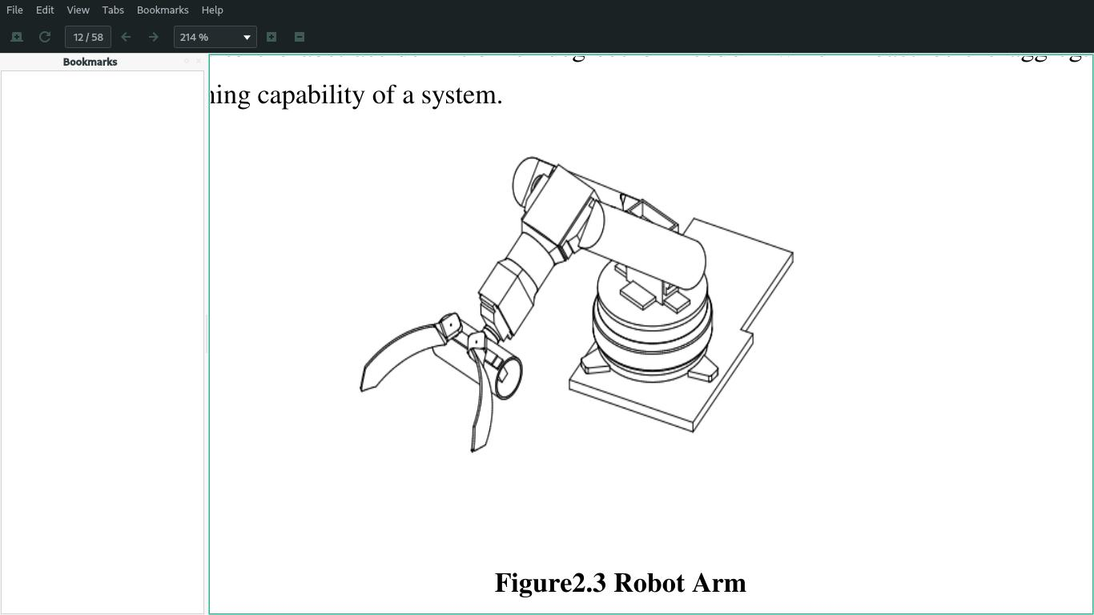

We are planning to make a robotic arm with **5/6 degree of freedom** which means :

* **Axis 1** - Rotates robot (at the base of the robotic arm)
* **Axis 2** - Forward / back extension of robot's lower arm
* **Axis 3** - Raises / lowers robot's upper arm
* **Axis 4** - Rotates robot's upper arm
* **Axis 5** - Raises / lowers wrist of robot's arm
* **Axis 6** - Rotates wrist of the robot's arm

(**not finalized yet**)

**WORK PLAN**

**PHASE 1 :**

**Designing :** Body structure designing using Autodesk 3ds Max.

**Fabrication :** Fabricate the design using 3d printer

**Assembling :** Creating the hardware model by assembling parts with the printed body

**Controlling :** In phase 1, The robotic arm is controlled through a remote thus ensures the working of the hardware, the microcontrolled used will be **Rasberry Pi**

**PHASE 2:**

**Software :** In this phase, 1 or 2 cameras are connected to the Rasberry Pi for sensing the enviroment(ultrasonic sensors will also be connected). Then the **source code will be altered to give the robotic arm the ability to identify faces and objects** in its surroundings

Rasberry Pi will be loaded with Raspbian( OS ) which will be used to program or automate the robotic arm by giving machine learning capabilities.

**REFERENCE**

* Mark S., Seth H. and Vidyasagar M., "Robot modeling and control", John Wiley & Sons, 2006.
* Clothier K.E. and Shang Y, “A geometric approach for robotic arm kinematics with hardware design, electrical design and implementation”, Journal of Robotics, Article ID 984823, Vol. 2010.
* C.-Y. Tsai, C.-C. Wong, C.-J. Yu, C.-C. Liu, and T.-Y. Liu, “A hybrid switched reactive-based visual servo control of 5-dof robot manipulators for pick-and-place tasks,” IEEE Systems Journal, vol. 9, no. 1, pp. 119–130, 2015.